EXPERIMENT – 07
Demonstrate virtualization by Installing Type-2 Hypervisor in your device, create and configure VM image with a Host Operating system (Either Windows/Linux) using virtual box.

Aim:
To demonstrate virtualization by installing a Type-2 Hypervisor (VirtualBox) and creating/configuring a VM image with a Host Operating System (Windows/Linux).
Procedure:
- Download and install Oracle VirtualBox on the host system (Type-2 Hypervisor).
- Launch VirtualBox and click New to create a new virtual machine.
- Enter the VM name, choose the Operating System type (Windows/Linux), and select version.
- Allocate required RAM size (e.g., 2 GB).
- Create a Virtual Hard Disk (VHD/VDI) and allocate desired storage (e.g., 20 GB).
- Mount the ISO image of the chosen OS (Windows/Linux).
- Start the VM and proceed with OS installation.
- Configure basic system settings (username, password, language, network).
- Verify the successful installation and functionality of the virtual machine.

Output: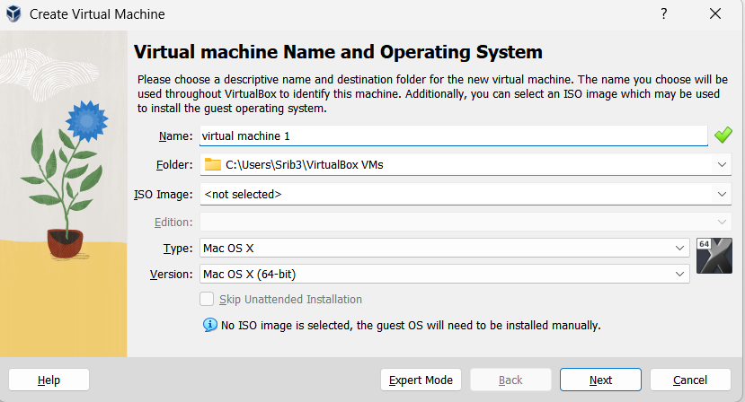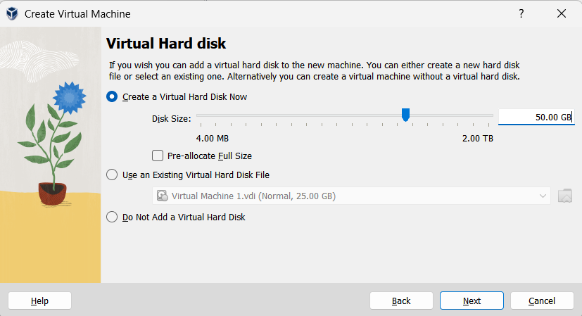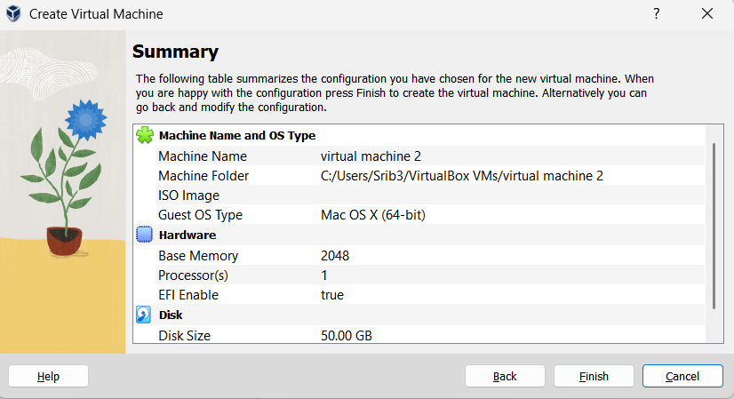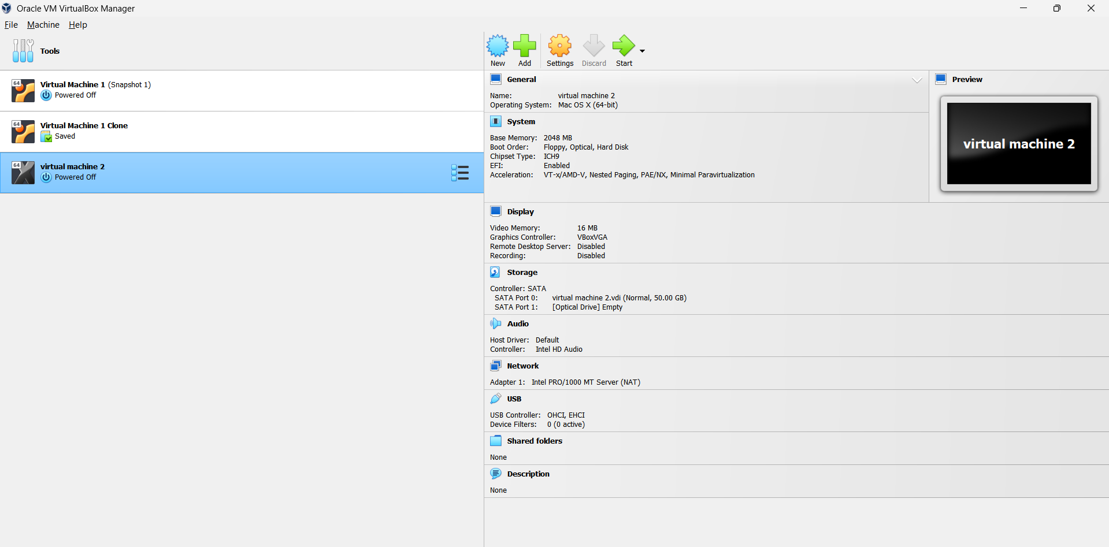
Result:
Virtualization was successfully demonstrated by installing VirtualBox (Type-2 Hypervisor), creating a VM, and configuring it with the chosen Host Operating System.

